**Database and Forms:**

**Admin**

Page: Login

Attribute: Username, Password

Page: Worker’s Information

Attribute: Name, id, username, password, email, address, phone number, salary, joining date.

Page: Add Worker

Attribute: Name, id, username, password, email, address, phone number, salary, joining date.

Page: Tourist Information

Attribute: Name, id, username, password, email, address, phone number, Type, Package, Payment method.

Page: Remove Worker

Attribute: Name, id, email, Comment

**Worker:**

Page: Login

Attribute: Username, Password

Page: Tourist Information

Attribute: Name, id, username, password, email, address, phone number, Type, Package, Payment method.

Page: Booking request

Attribute: Name, id, username, email, Package, Payment.

**Tourist:**

Page: Login Page

Attribute: Username, Password

Page: Create account

Attribute: Name, id, username, password, email, address, phone number, Type, Package, Payment method.

Page: Package

Attribute: Name.

Page: Standard

Attribute: Transport, Hotel Name, Room type, Price, Destination, Duration

Page: Moderate

Attribute: Transport, Hotel Name, Room type, Price, Destination, Duration

Page: Premium

Attribute: Transport, Hotel Name, Room type, Price, Destination, Duration

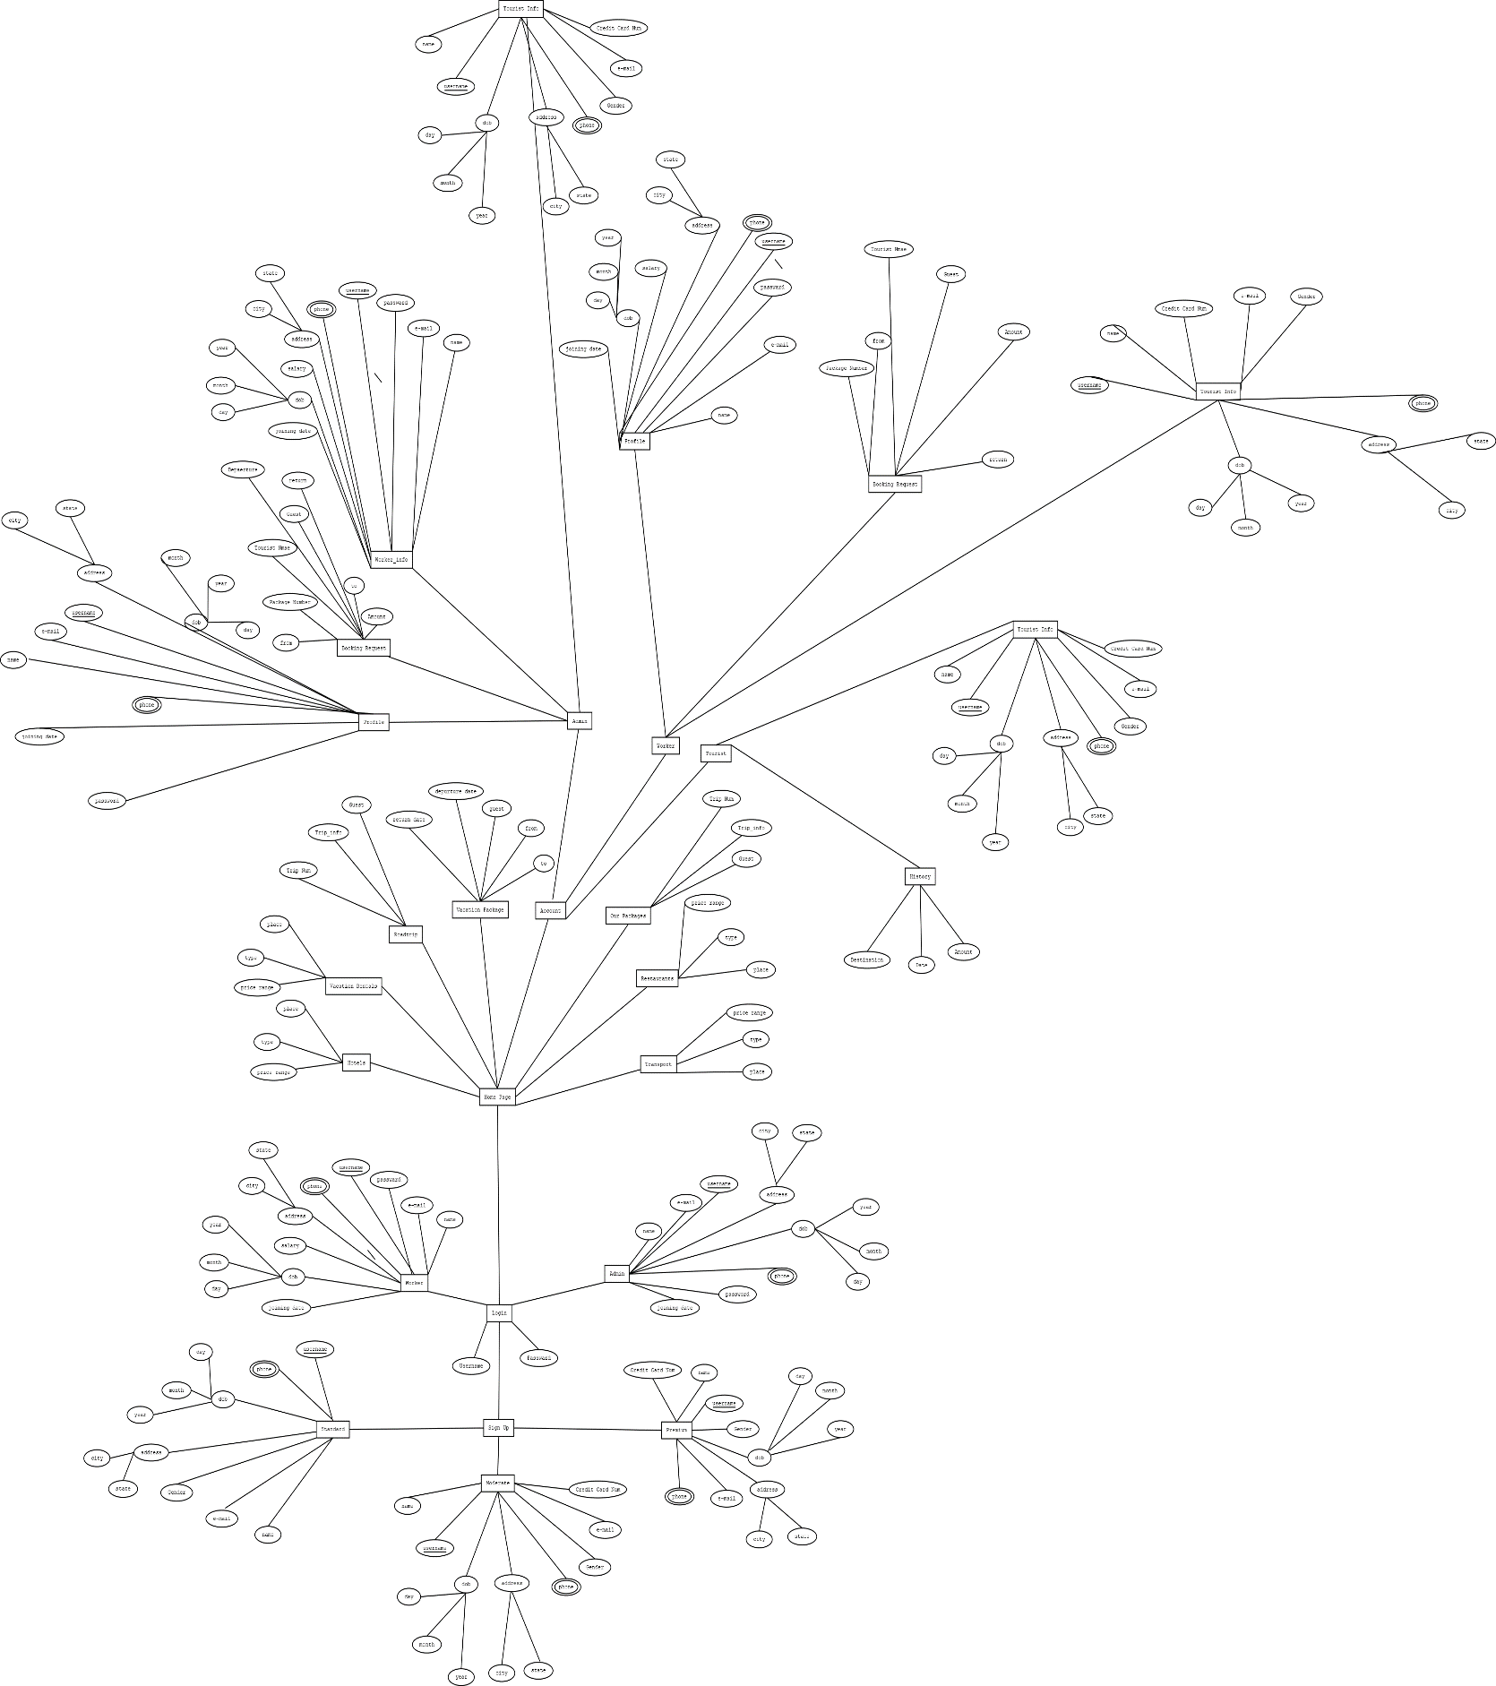**ER Diagram**